Chippewa Powwow 2023 Nutrition Subsidy Form

COTTFN Community Nutrition Services is offering a subsidy for all food vendors who choose to sell fruit and vegetable options at their booths at the Chippewa Powwow. The subsidy will provide up to $100 off the food vendor fee ($50 if a qualifying vegetable is being served and $50 if a qualifying fruit is being served.)

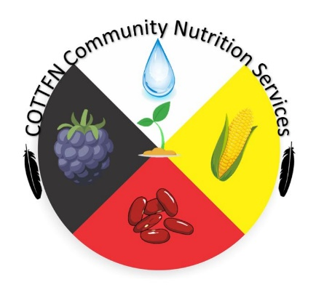
Subsidy qualifications:

- Must be a food vendor set-up at the Chippewa Powwow
- Must be selling a food or dish comprised of qualifying foods
- Qualifying foods/dishes must be visible on the food vendors menu
- The menu item must be stocked enough to last at least 50 orders

Verified Menu Items:

Fruits-_______________________________ Vegetables-_______________________________
($50) ($50)

______________________________ (name of food booth) has participated in the 2023 Powwow Nutrition Subsidy and has met all grounds for qualification for the amount of $________.
 Food vendor has been provided a maanwang/gitigaanan promotional sign

I agree that all information above is true and accurate,

_______________________________ ______________________________
Food Vendor Signature Dietitian Signature

