June 23, 2023

Attention: Chippewa Powwow Committee,

My name is Marley Fisher and I’m a dietitian working at the health centre, my program is called Community Nutrition Services. Throughout 2023, I’ve been running initiatives to improve the nutritional quality of foods served by the health center, school, and daycare centers.

In an effort to promote more nutritious options at well-attended cultural and social events like the annual powwow, I’d like to make a proposal to the committee:

My program will provide a subsidy for food vendors who choose to sell fruit and vegetable options at their booths. My program will provide up to $100 off the food vendor fee ($50 if a qualified vegetable is being served and $50 if a qualified fruit is being served.)

To qualify:
- Must be a food vendor set-up at the Chippewa Powwow
- Must be selling a food or dish comprised of qualifying foods
- Qualifying foods/dishes must be visible on the food vendors menu
- The menu item must stocked enough to last at least 50 orders

Proposed process:
- A public flyer will go out in the August Mazinigan promoting the initiative
- When food vendors register, they will be told about the initiative and be able to access the flyer, if requested
- The dietitian will join the assigned vendors fee collector (AVFC) at the food booths during the powwow and determine who qualifies for the subsidy and the amount they are entitled to receive off their vendors fee
- The dietitian and AVFC will confirm total subsidy amount provided and,
- Community Nutrition Services will transfer that amount to the powwow account

Overall, this will not cost the powwow committee any additional funds, it does not force food vendors to change their menus, however it does provide an opportunity for food vendors to reduce the cost of their fee and will allow more nutritious choices for our community and visitors.
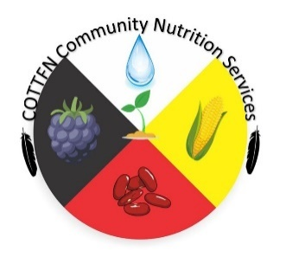
Miigwech for your consideration,
Please do not hesitate to contact me if you have any further questions,

Marley Fisher

List of Qualifying Foods/Dishes

Fruits | Vegetables
Any whole fruit (ex. banana, apple, orange) | Any leafy green salad
Fruit cups (fresh or served in 100% fruit juice) | Raw veggies (ex. carrot/celery sticks)
Fruit kabobs | Cooked vegetables (sautéed, grilled, baked, boiled)
Real fruit smoothies (little to no sugar added) | Corn on the cob
Unsweetened apple or fruit sauce packets or cups | Baked potatoes
Dried fruit in a salad or low-sugar trail mix | homemade coleslaw

Strawberry drink made with minimal sap water or maple syrup

DOES NOT QUALIFY: fruit juice or fruit drink, fruit gummies/snacks, vegetable toppings (ex. on burgers or Indian Tacos), Strawberry drink made with granular sugar, deep-fried vegetables, fruit-covered in candy or chocolate, fries.

The community dietitian will make the final call on foods and dishes that qualify based on their cultural significance and fat, sugar, and salt content.

